Course 4

EC2 Instance :

Amazon Elastic Compute Cloud : this module provided by AWS which help to provide virtual server machine. While creating EC2 instance we can configure our machine information as ie OS (linux, mac, window), with RAM and memory space etc. once we created EC2 instance that instance provide us public as well as private IP Address.

<http://localhost:9090/>

<http://127.0.0.1:9090/>

default IP Address for all local machine

once machine ie instance of EC2 instance ready then we need to connect that machine using SSH click or through browser.

Then we need to install all required software which help to deploy our application.

To run jar file which we uploaded in S3 bucket we need java software to install in EC2 instance.

Steps to create EC2 instance.

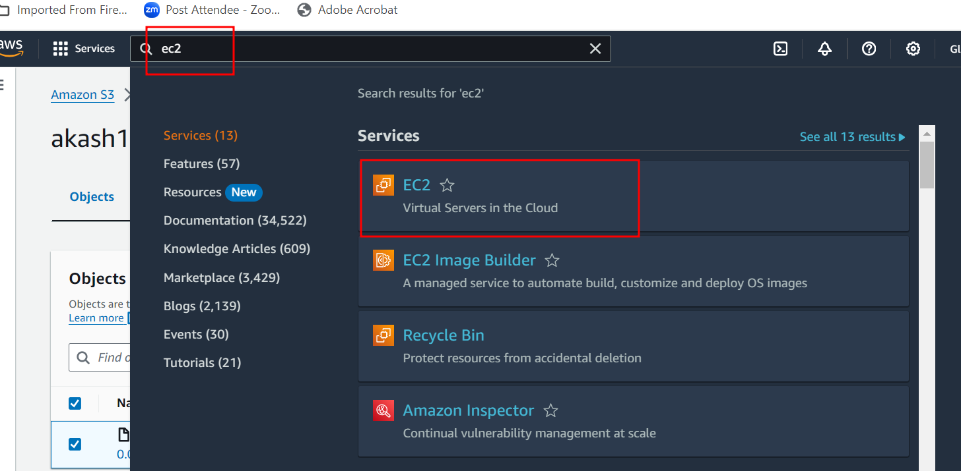

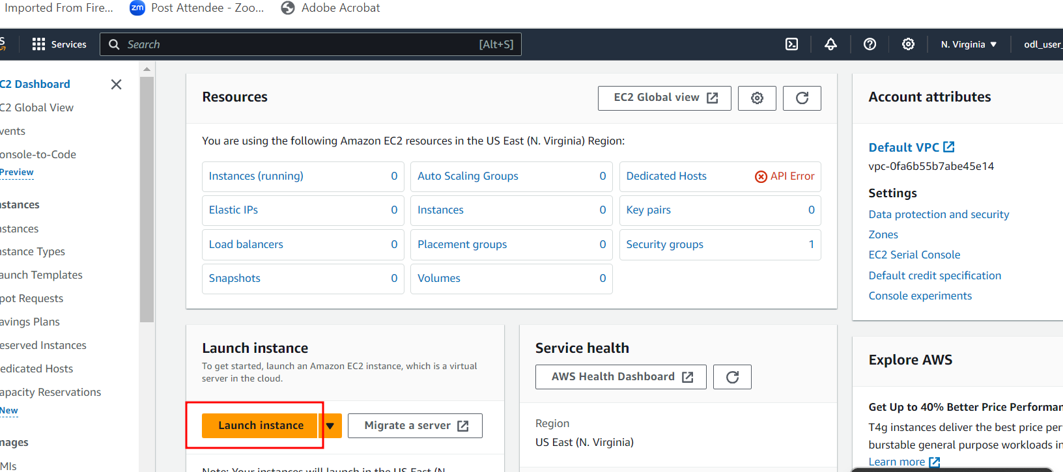

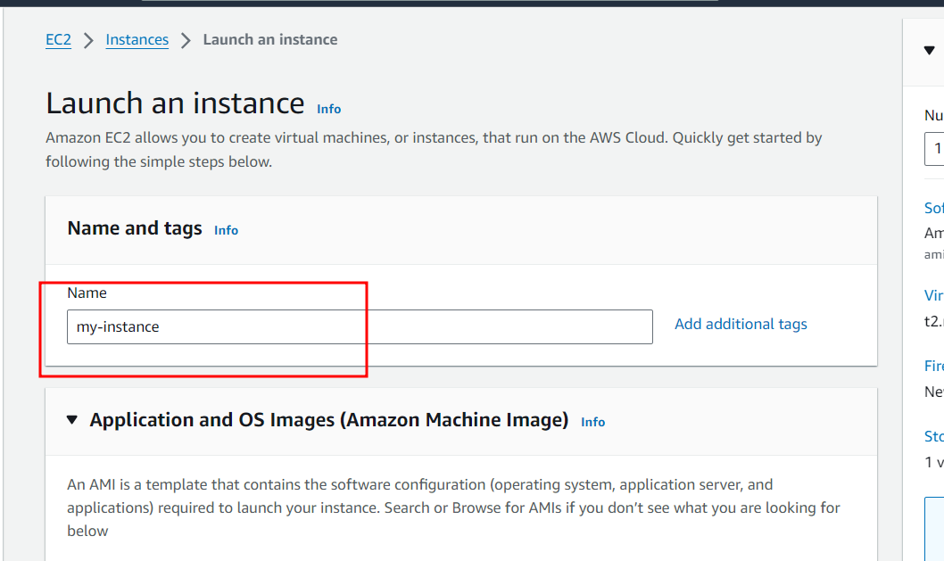

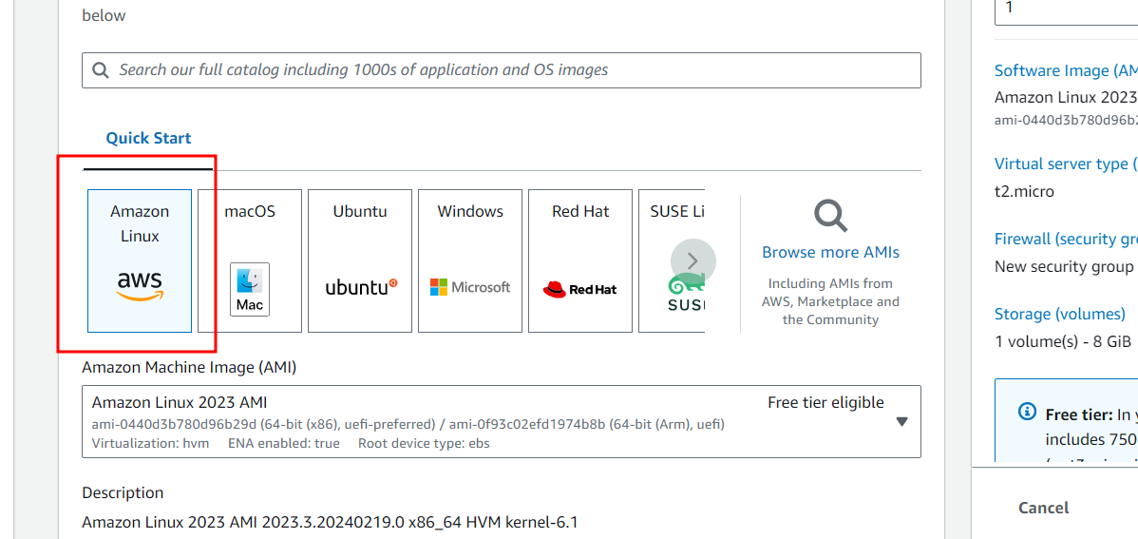

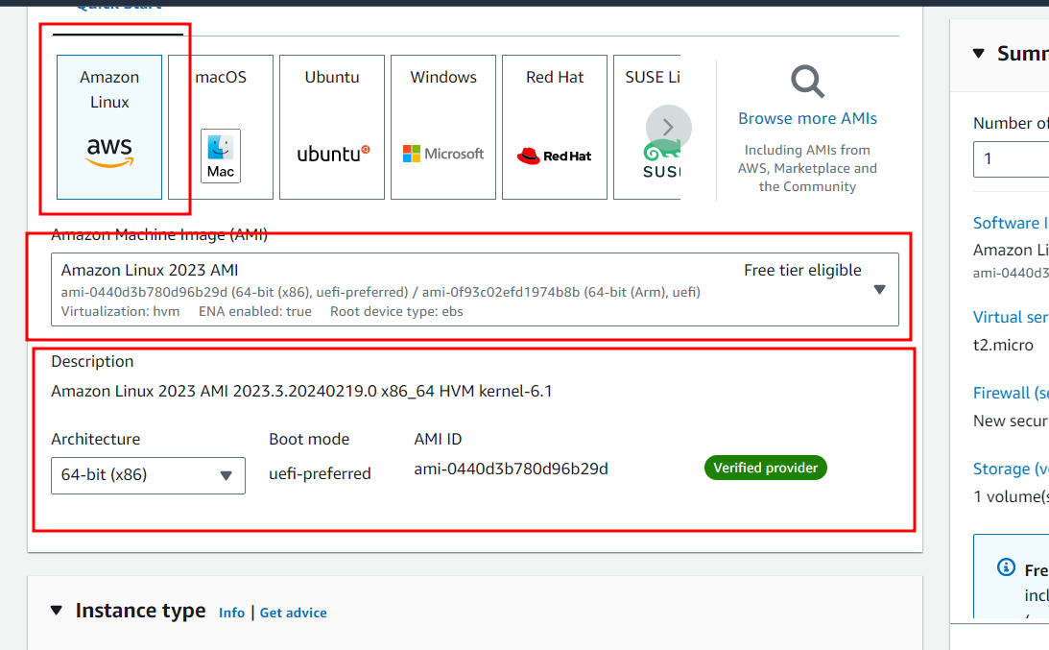

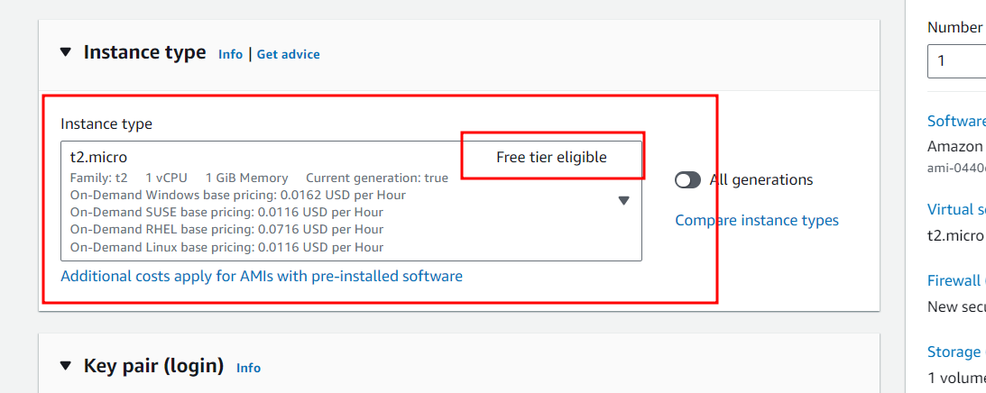

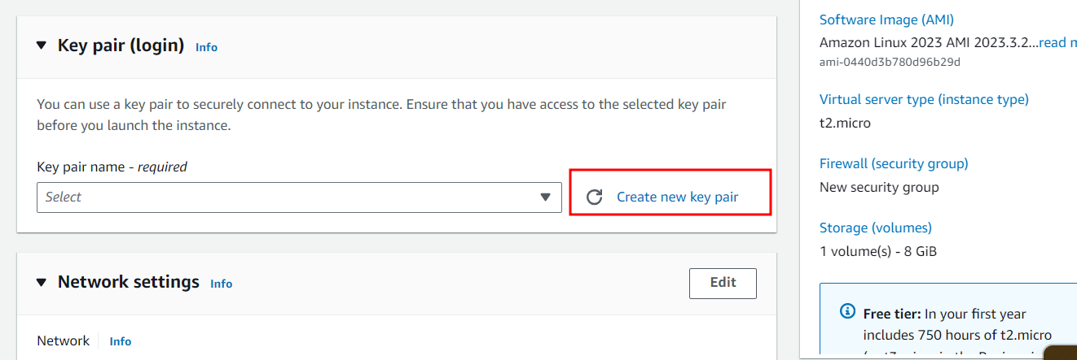

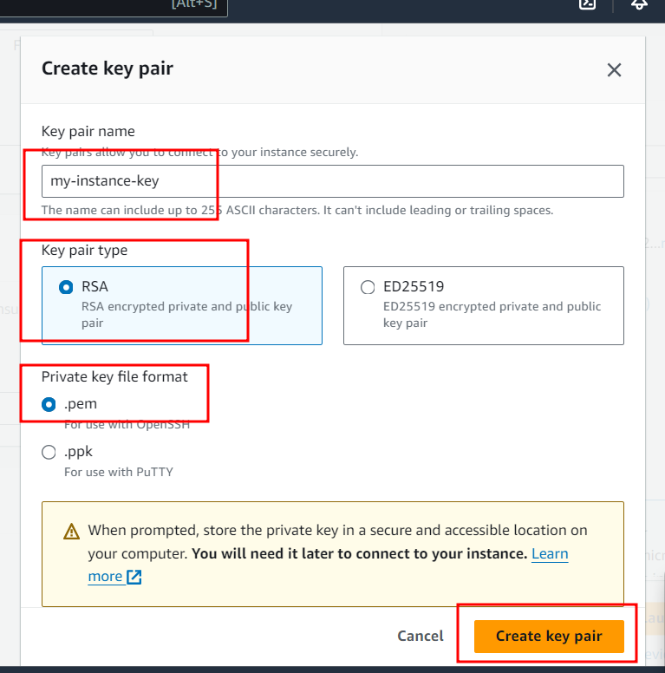

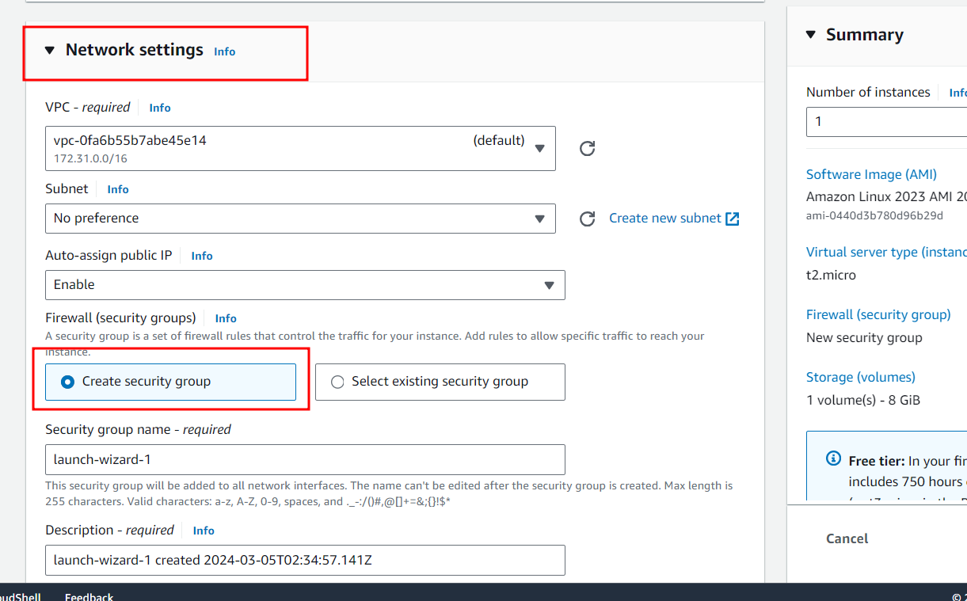

By default it will create new security group with port number open as 22.

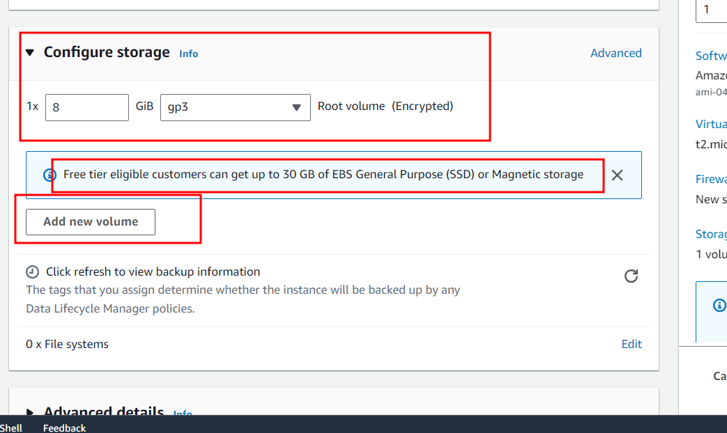

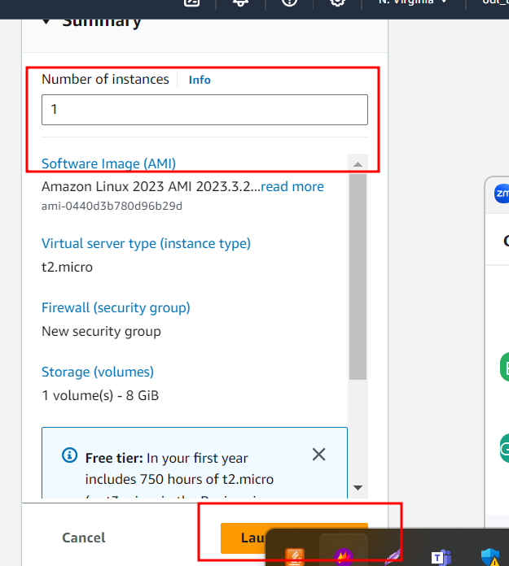

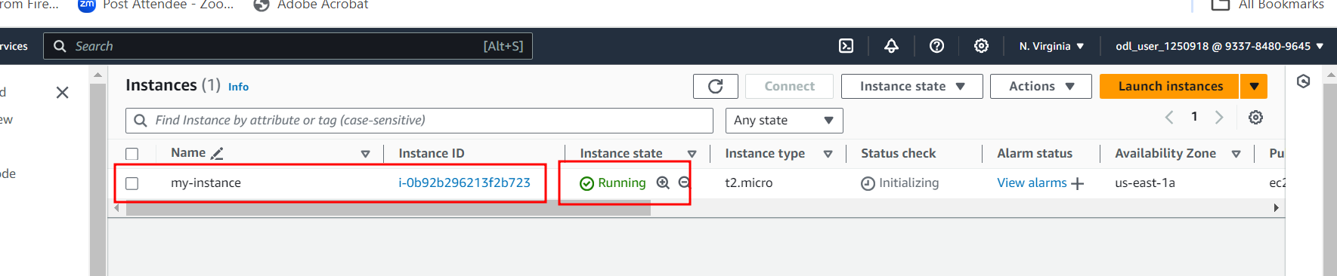

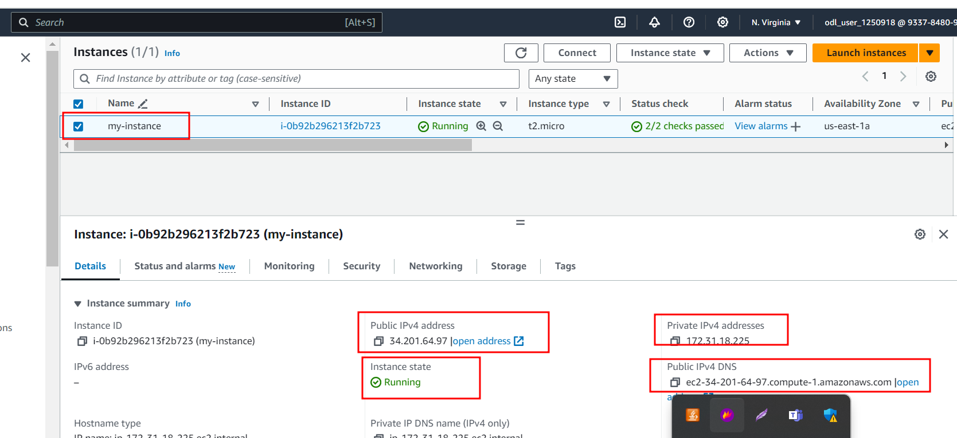

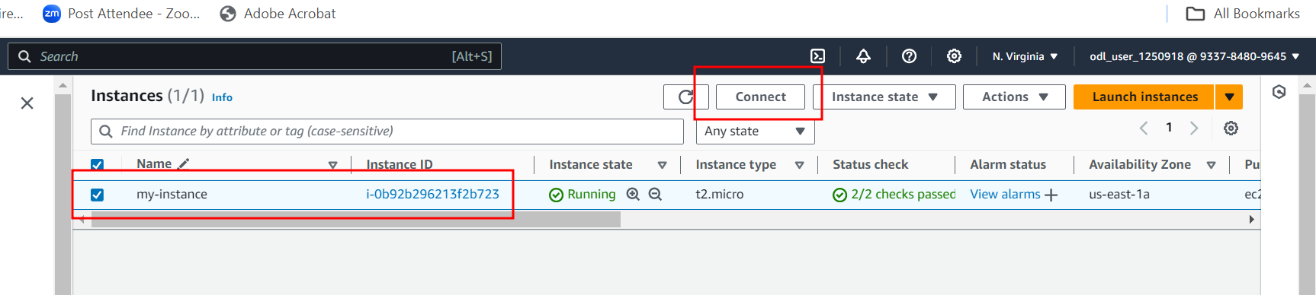

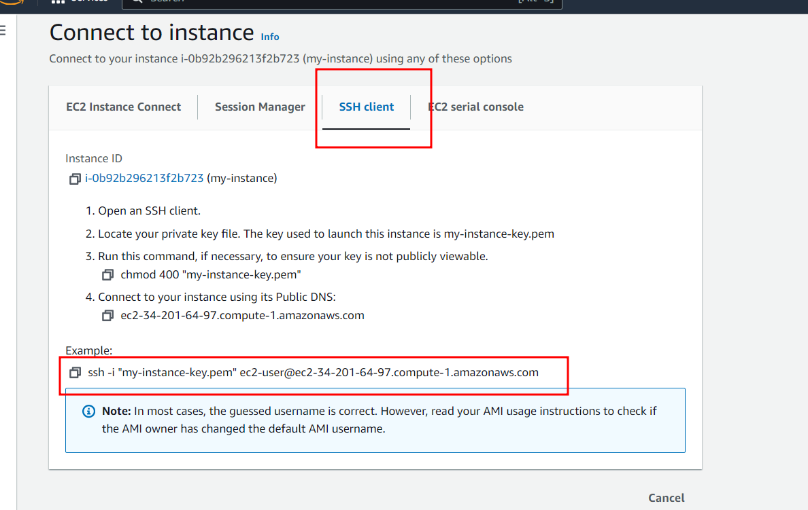

Open terminal (non window) or gitbash (window ) user and use SSH command to connect Ec2 instance. Make sure .pem key present in that location.

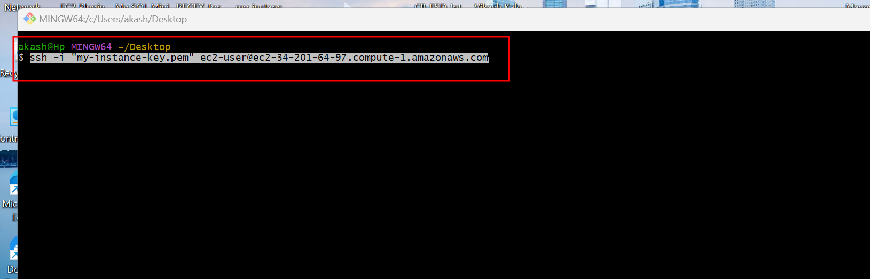

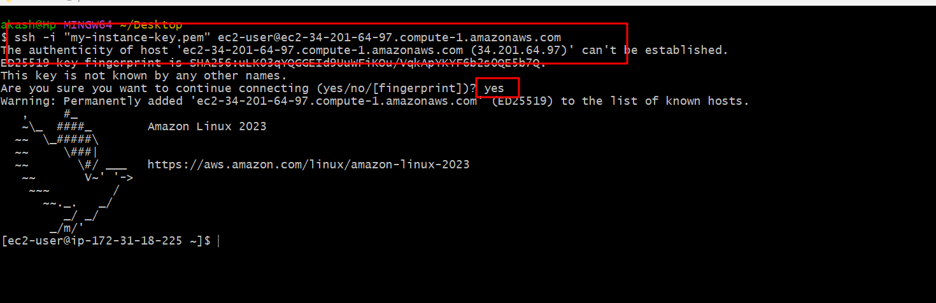

Once we connected EC2 instance using SSH client terminal now we need to download jar file present in S3 bucket.

Copy URL of S3 bucket jar file.

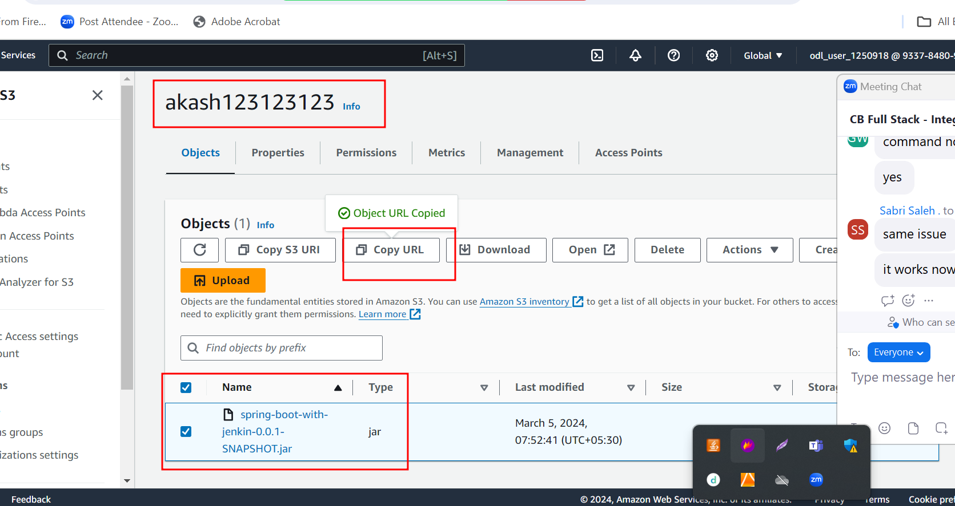

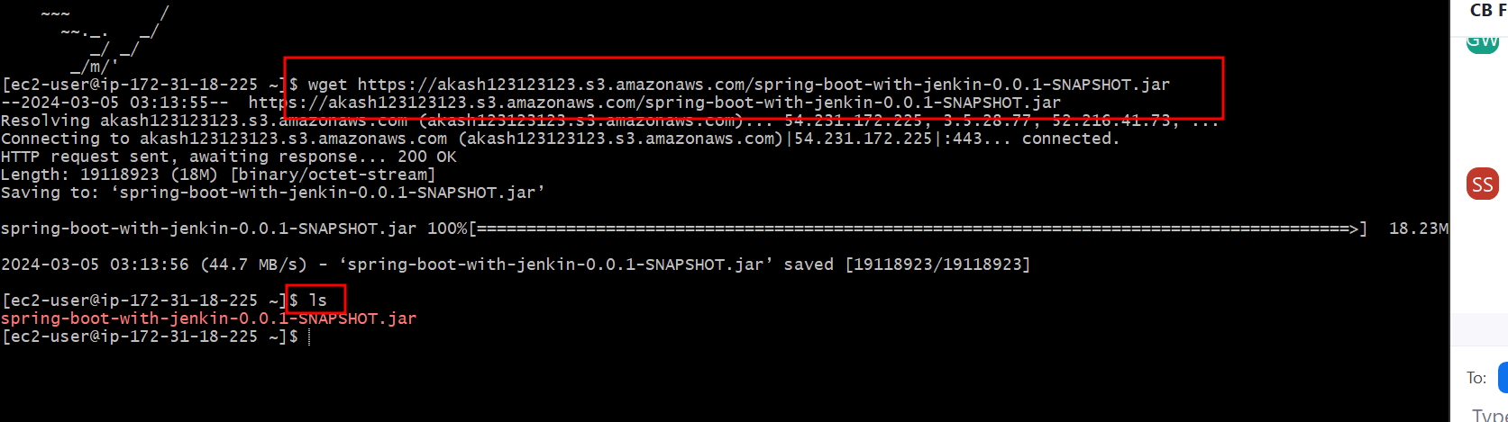

Now we need to install java software in EC2 instance to run the jar file.

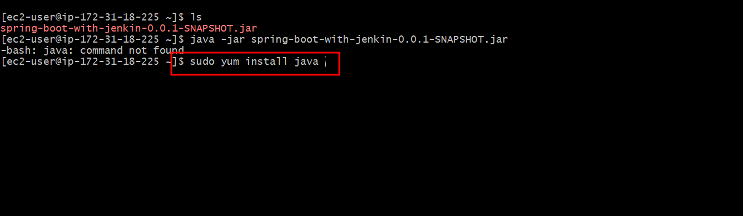

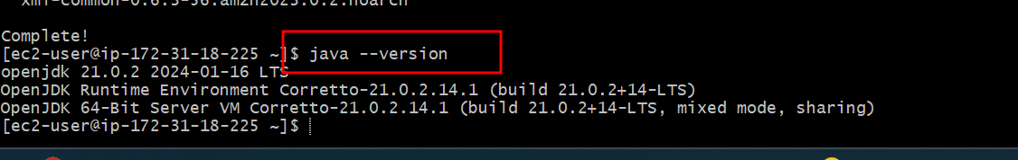

Now we are running spring boot jar file using java commands.

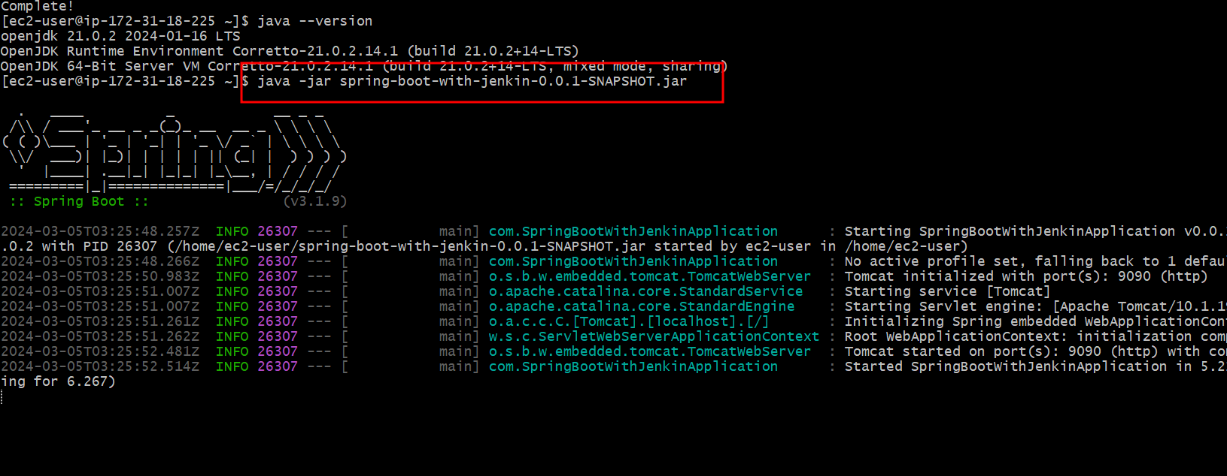

After run the application we need to check the public IP Address of your EC2 instance.

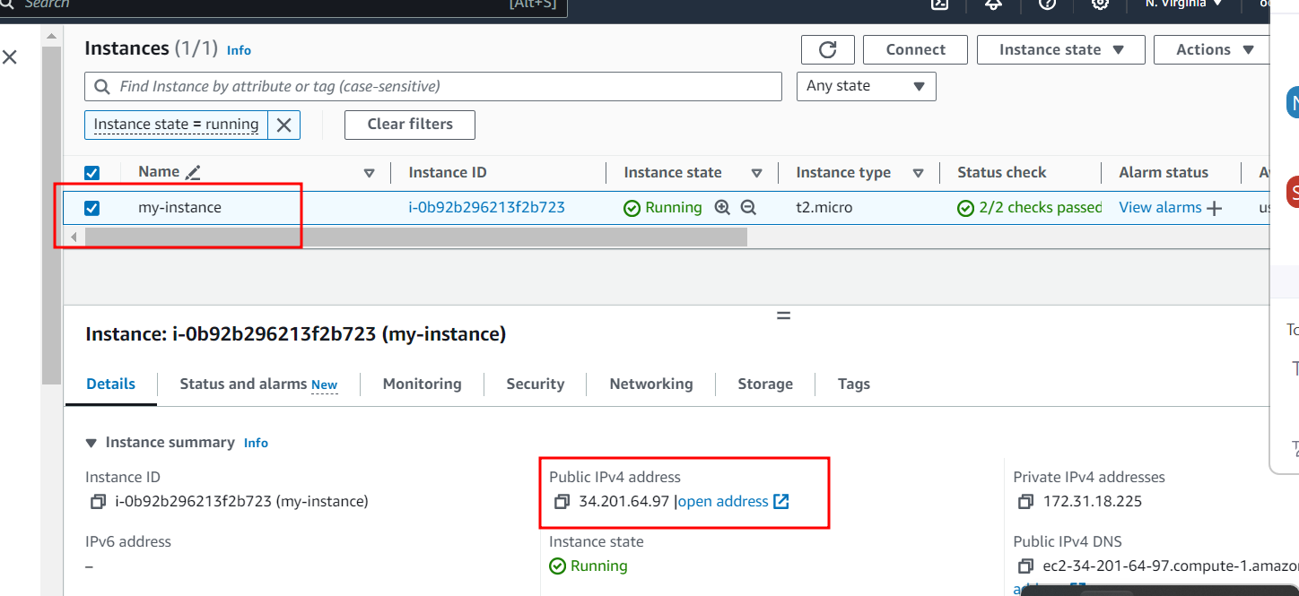

Copy ip address

<http://34.201.64.97:9090/simple>

by default EC2 instance open only one port number ie 22 which help to connect EC2 instance using SSH client. Our application running on 9090 port number So security group we need to open 9090 port number.

Steps to open 9090 port number in security group.

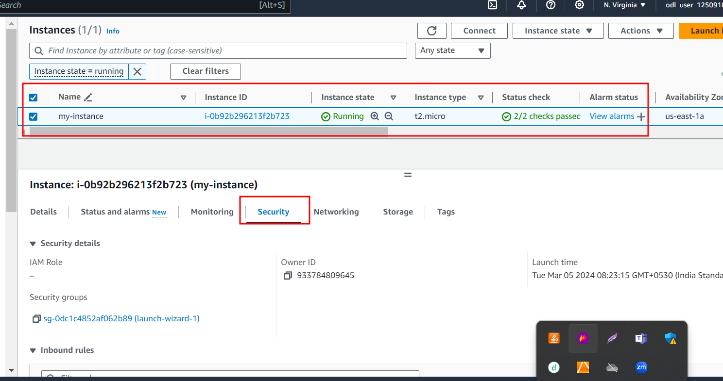

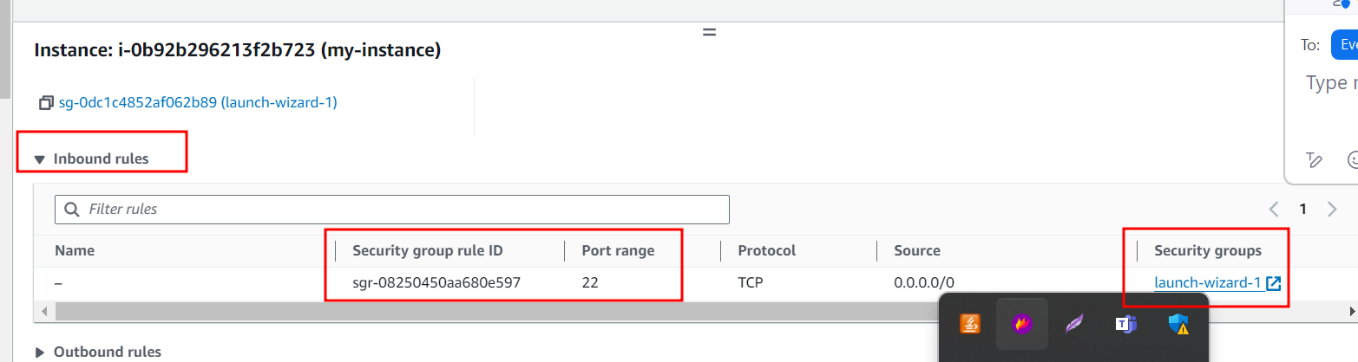

Once you click on launch wizard it will open the security group dashboard in another tab.

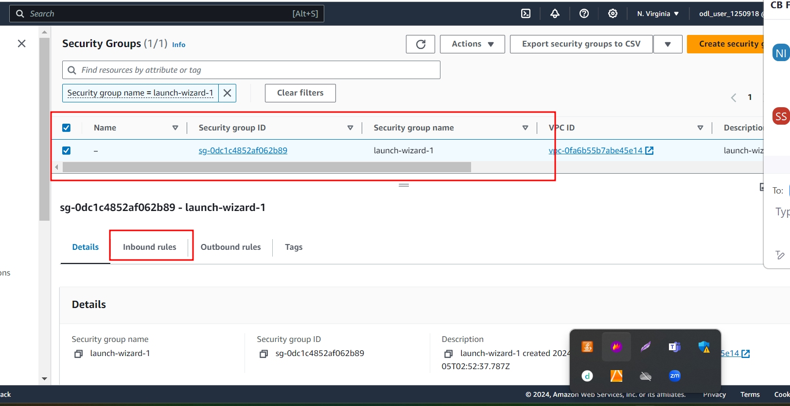

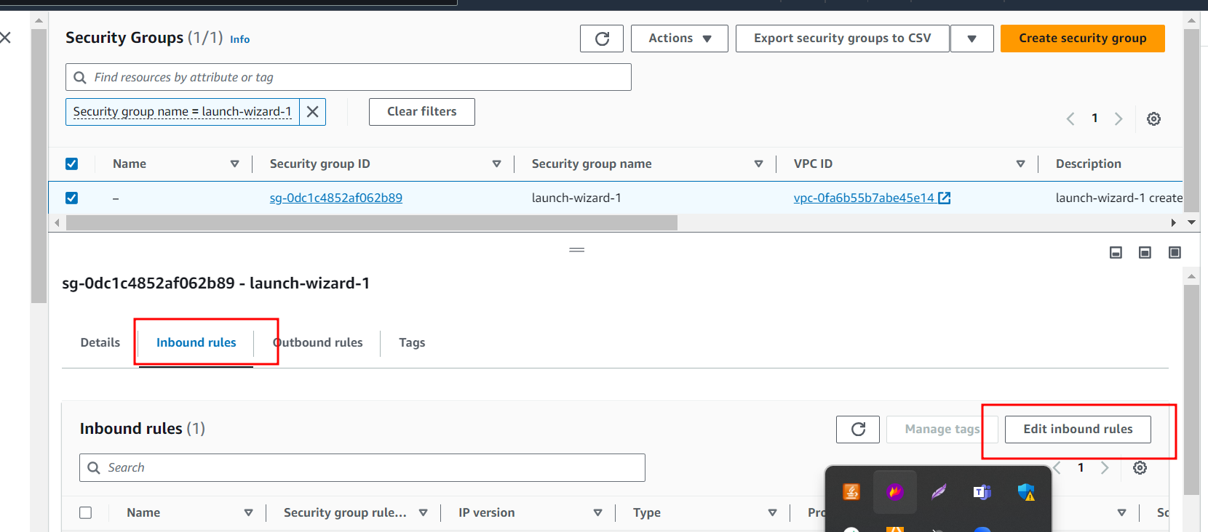

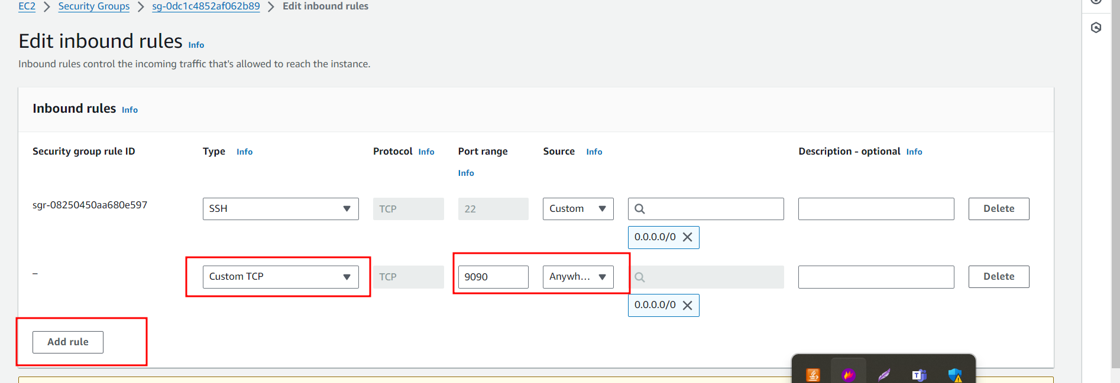

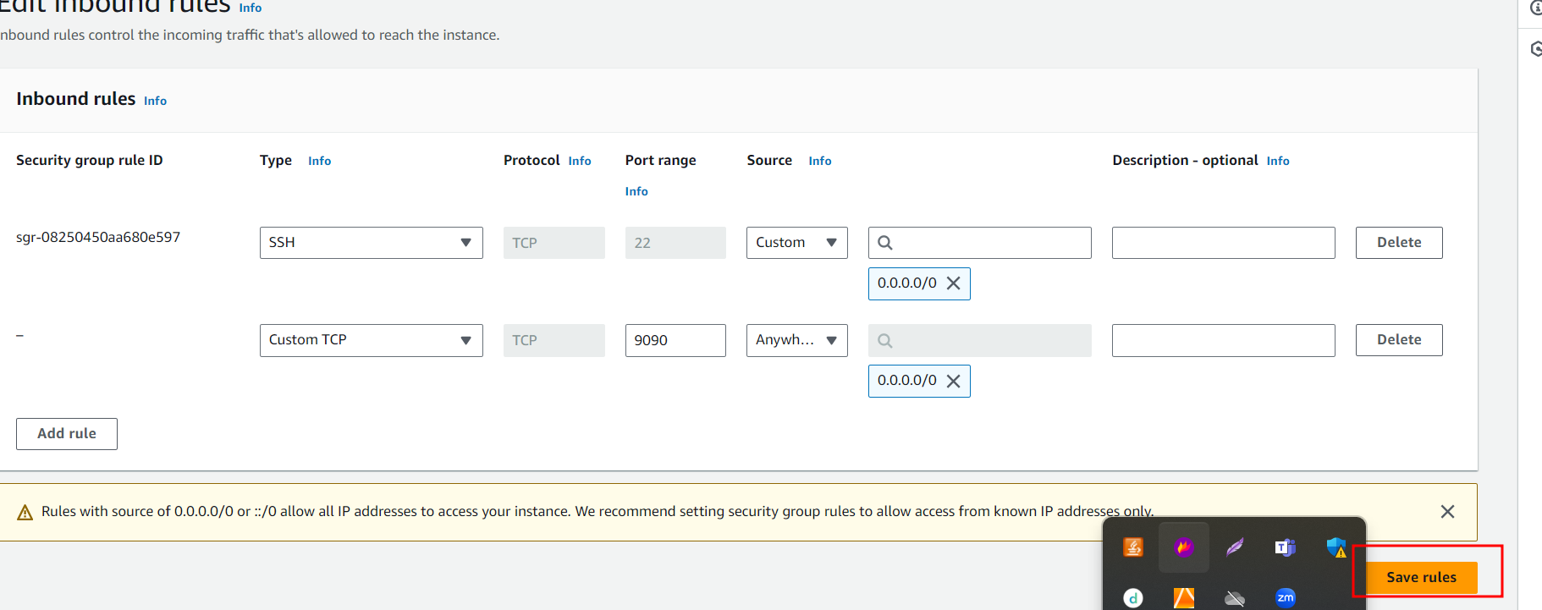

After open 9090 port number in our EC2 instance you can access the application using

<http://publicIdAddpress:9090/Path>

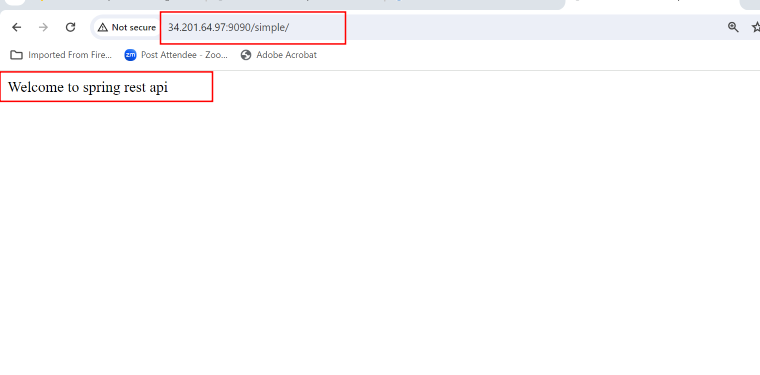

But in this approach. If we want to any changes in application in our local machine. We need to re-create new jar file and that jar file we need to upload in S3 bucket. Using wget command we need download updated jar file and run once again that jar file to get new update.

2nd option

Rather than uploading jar file in s3 bucket we can push this spring boot project in git hub repository and in ec2 instance we can pull the project and build maven project itself in Ec2 instance.

Create new rest api and test in local machine.

Then push this project to git hub account.

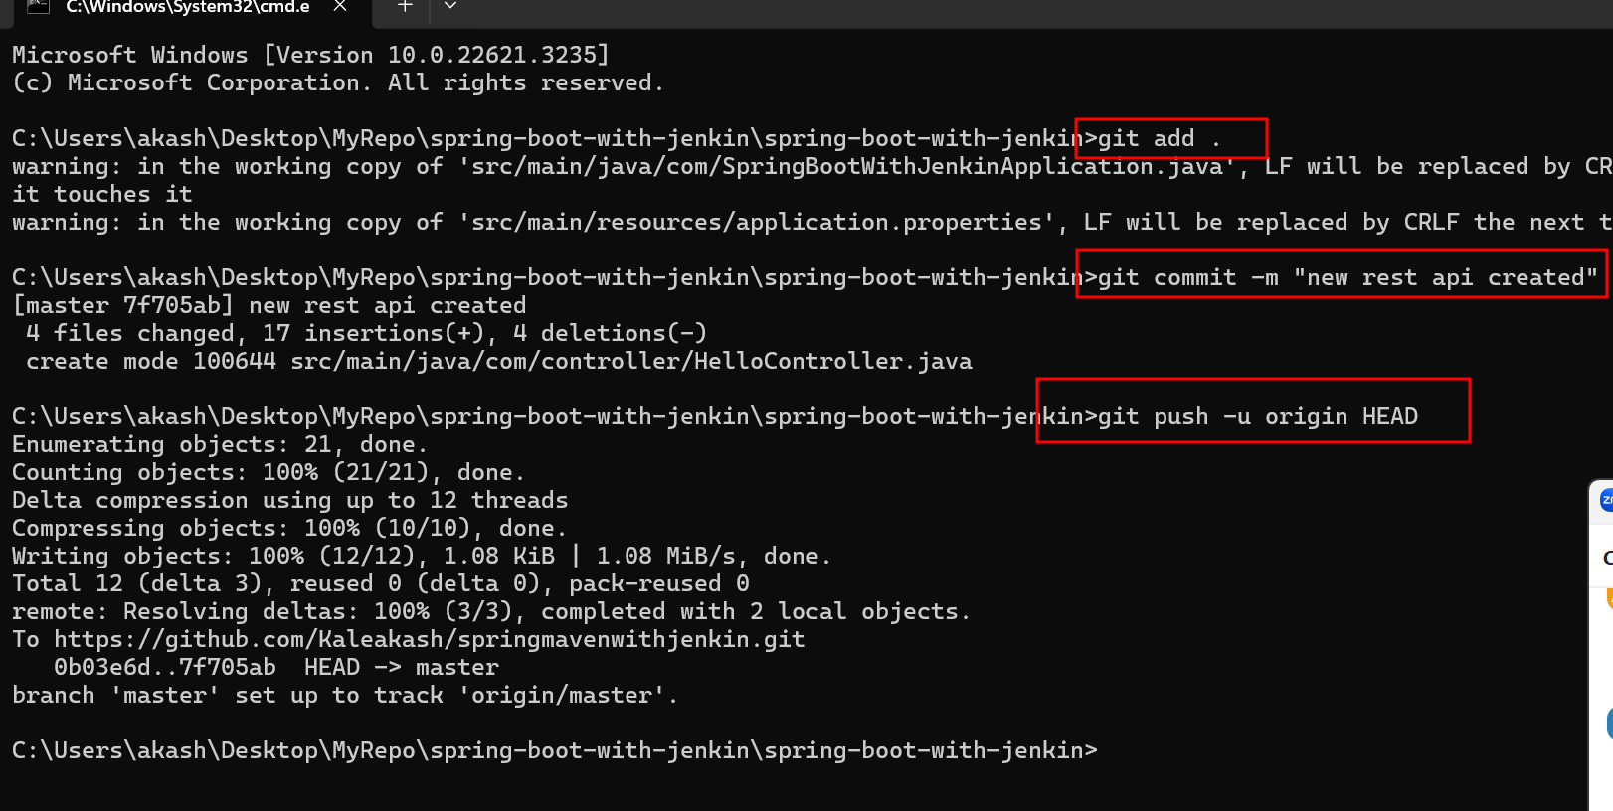

<https://github.com/Kaleakash/springmavenwithjenkin.git>

Now we need to install git software in Ec2 instance.

Using git you can clone the project

Below command is use to install git in ec2 instance.

sudo yum install git

once you install git in EC2 instance please clone your spring boot project present in github account.

git clone URL

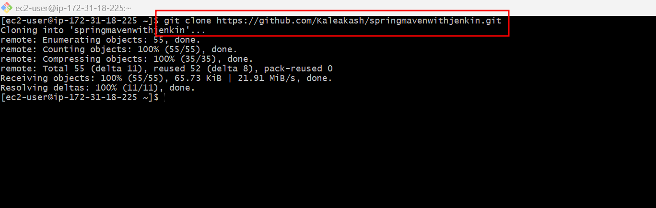

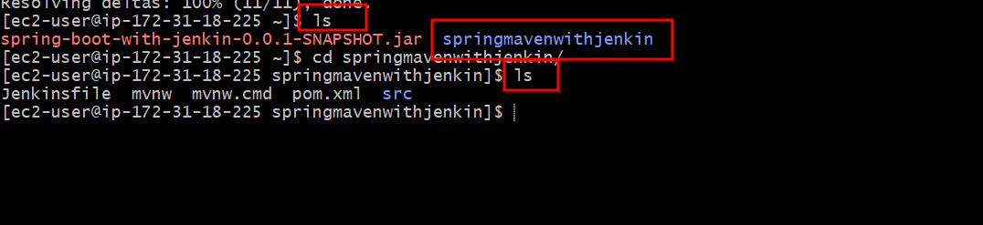

Now we need to install maven software to build the project.

Command to install maven in Ec2 instance.

sudo yum install maven

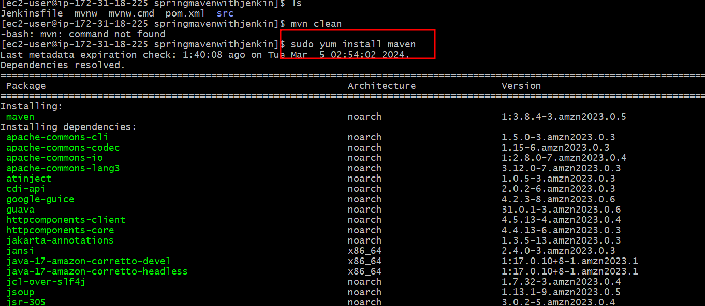

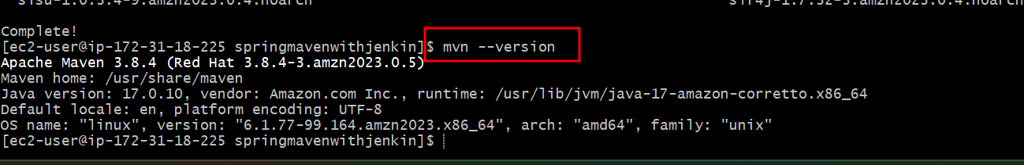

Now we need to create jar file using mvn package command.

Make sure your EC2 terminal present inside maven project with pom.xml

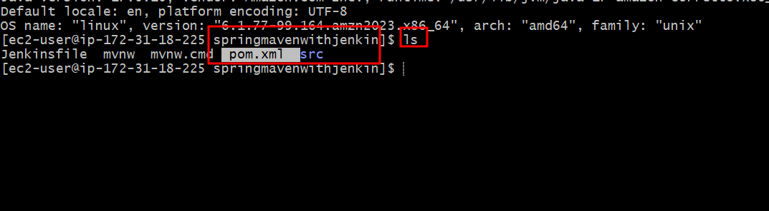

If we want we can execute maven command as

mvn clean

mvn compile

mvn test

mvn package

after jar file created (jar file present inside target folder).

If we get any error while creating jar file please re-check your project with source code as well as testing code and once again push the project and in Ec2 instance pull the project.

Once jar file created by default jar file create inside target folder.

